**CANADA COMPUTERS DATABASE ANALYSIS**

**Student Name: Brian Bantigue**

**Instructor: Bill Xu**

**Database Name:** canadacomputers

**Database Management System:** SQL Server

**GitHub link:**

<https://github.com/bignatue/cbcproject1>

**Table of Content:**

1. Title

2. Index

3. Schema

4. Account Type

6. Account

8. Account Details

10. Branch

11. Category

12. Brand

13. Product Details

15. Product Miscellaneous

16. Product Miscellaneous Content

18. Product Stocks and Sales Order Status

19. Sales Orders and Sales Order Items

21. Presets and Triggers

22. Diagram

**Schema:**

Product

Sales

Script:

IF SCHEMA_ID('hr') IS NULL

EXEC ('CREATE SCHEMA hr');

IF SCHEMA_ID('product') IS NULL

EXEC ('CREATE SCHEMA product');

IF SCHEMA_ID('sales') IS NULL

EXEC ('CREATE SCHEMA sales');

**ACCOUNT TYPE**

**TABLE NAME: accountType**

|  |  |  |  |
| --- | --- | --- | --- |
| **NAME** | **TYPE** | **ALLOW NULL** | **DESC/ATTRIBUTES** |
| accountTypeID | int | NOT NULL | PRIMARY KEY/IDENTITY |
| accountName | varchar(40) | NOT NULL |  |

Script:

CREATE TABLE accountType(

accountTypeID INT NOT NULL PRIMARY KEY IDENTITY,

accountTypeName VARCHAR(40) NOT NULL

);

*RELATIONS*

|  |  |  |
| --- | --- | --- |
| **Foreign table** | **Primary table** | **Join** |
| account | accountType | accountType. accountTypeID = account.accoundID |

**ACCOUNT STATUS**

**TABLE NAME: accountStatus**

|  |  |  |  |
| --- | --- | --- | --- |
| **NAME** | **TYPE** | **ALLOW NULL** | **DESC/ATTRIBUTES** |
| accountStatusID | int | NOT NULL |  |
| label | varchar(12) | NOT NULL |  |

Script:

CREATE TABLE accountStatus(

accountStatusID INT NOT NULL PRIMARY KEY IDENTITY,

label VARCHAR(12) NOT NULL

);

*RELATIONS*

|  |  |  |
| --- | --- | --- |
| **Foreign table** | **Primary table** | **Join** |
| account | accountStatus | accountStatus. accountStatusID = account.accoundID |

**ACCOUNT**

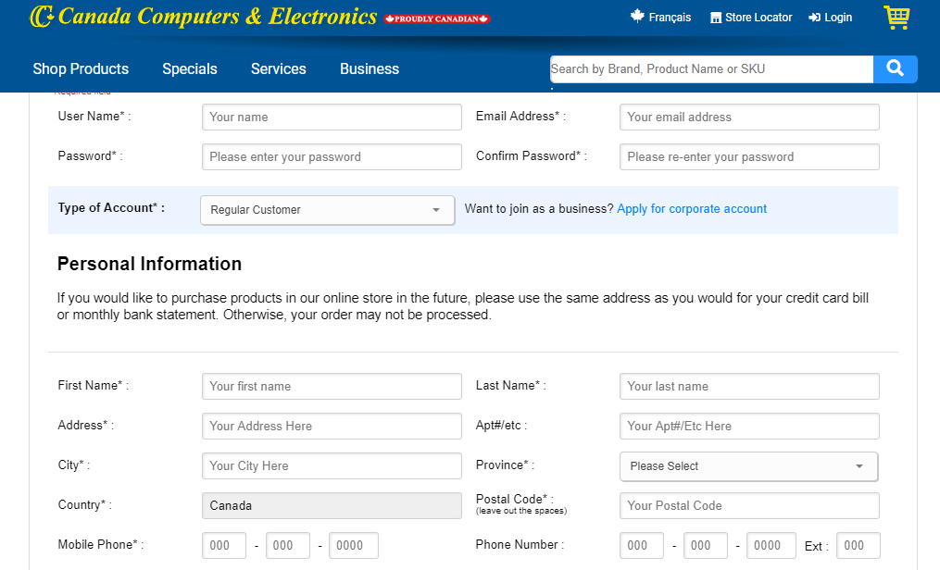

**TABLE NAME: account**

|  |  |  |  |
| --- | --- | --- | --- |
| **NAME** | **TYPE** | **ALLOW NULL** | **DESC/ATTRIBUTES** |
| accountID | int | NOT NULL | PRIMARY KEY/IDENTITY |
| username | varchar(12) | NOT NULL |  |
| password | varchar(12) | NOT NULL |  |
| email | varchar(12) | NOT NULL |  |
| accountType | int | ALLOW | FOREIGN KEY |
| accountStatus | int | ALLOW | FOREIGN KEY |

Script:

CREATE TABLE account(

accountID INT NOT NULL PRIMARY KEY IDENTITY,

username VARCHAR(12) NOT NULL,

[password] VARCHAR(12) NOT NULL,

email VARCHAR(12) NOT NULL,

accountTypeID INT NULL FOREIGN KEY REFERENCES accountType(accountTypeID) ON DELETE CASCADE ON UPDATE CASCADE,

accountStatusID INT NULL FOREIGN KEY REFERENCES accountStatus(accountStatusID) ON DELETE CASCADE ON UPDATE CASCADE

);

*RELATIONS*

|  |  |  |
| --- | --- | --- |
| **Foreign table** | **Primary table** | **Join** |
| account | accountStatus | accountStatus. accountStatusID = account.accoundID |
| account | accountType | accountType. accountTypeID = account.accoundID |
| sales.orders | account | sales.orders.orderID = account.accoundID |
| accountDetails | account | accountDetails.accountID = account.accoundID |

**TABLE NAME: accountCreated**

|  |  |  |  |
| --- | --- | --- | --- |
| **NAME** | **TYPE** | **ALLOW NULL** | **DESC/ATTRIBUTES** |
| accountID | int | NOT NULL |  |
| dateCreated | varchar(12) | NOT NULL |  |

Script:

CREATE TABLE accountCreated (

accountID INT,

dateCreated NVARCHAR(120)

);

**ACCOUNT DETAILS**

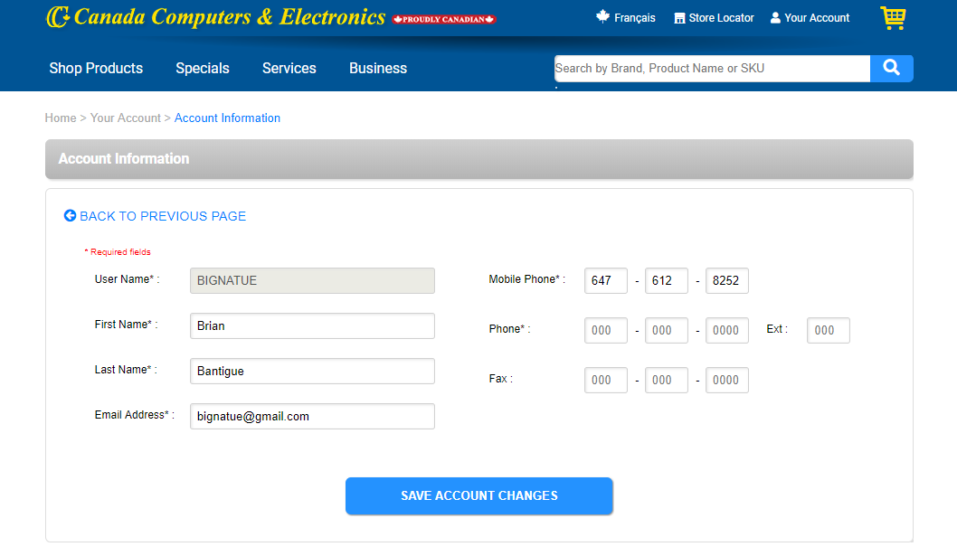

**TABLE NAME: accountDetails**

|  |  |  |  |
| --- | --- | --- | --- |
| **NAME** | **TYPE** | **ALLOW NULL** | **DESC/ATTRIBUTES** |
| accountID | int | NOT NULL | FOREIGN KEY |
| firstName | varchar(120) | NOT NULL |  |
| lastName | varchar(120) | NOT NULL |  |
| aptNumber | varchar(6) | ALLOW |  |
| city | varchar(32) | ALLOW |  |
| province | varchar(32) | ALLOW |  |
| country | varchar(32) | ALLOW |  |
| postalCode | varchar(12) | ALLOW |  |
| mobileNumber | Int | ALLOW |  |
| phoneNumber | Int | ALLOW |  |

Script:

CREATE TABLE accountDetails(

accountID INT NULL FOREIGN KEY REFERENCES account(accountID) ON DELETE CASCADE ON UPDATE CASCADE,

  firstName TINYINT NOT NULL,

  lastName VARCHAR(20) NOT NULL,

  aptNumber VARCHAR(6) NULL,

  city VARCHAR(32) NULL,

  province VARCHAR(32) NULL,

  country VARCHAR(32) NULL,

  postalCode VARCHAR(12) NULL,

  mobilePhone INT NULL,

  phoneNumber INT NULL

);

*RELATIONS*

|  |  |  |
| --- | --- | --- |
| **Foreign table** | **Primary table** | **Join** |
|  | account | accountDetails. accountID = account.accoundID |

**BRANCH**

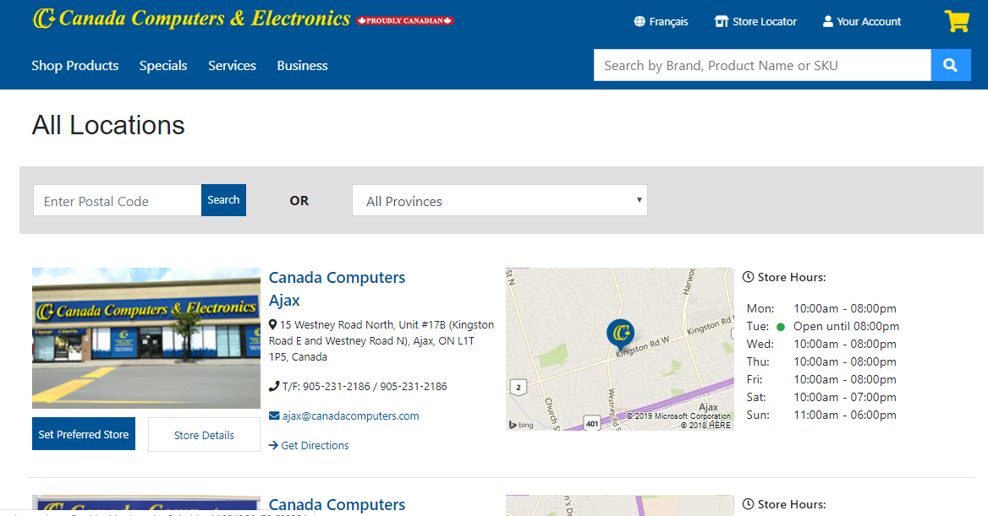

**TABLE NAME: branch**

|  |  |  |  |
| --- | --- | --- | --- |
| **NAME** | **TYPE** | **ALLOW NULL** | **DESC/ATTRIBUTES** |
| branchID | int | NOT NULL | PRIMARYKEY/INDENTITY |
| branchName | varchar (40) | NOT NULL |  |
| Branch_Address | varchar(120) | NOT NULL |  |
| email | varchar(120) | NOT NULL |  |
| contactNumber | varchar(120) | NOT NULL |  |

Script:

CREATE TABLE branch(

branchID INT NOT NULL PRIMARY KEY IDENTITY(1,1),

branchName VARCHAR(40) NOT NULL,

branch_Address VARCHAR(120) NOT NULL,

email VARCHAR(120) NOT NULL,

contactNumber VARCHAR(20) NOT NULL

);

*RELATIONS*

|  |  |  |
| --- | --- | --- |
| **Foreign table** | **Primary table** | **Join** |
| product.stocks | branch | branch.branchID = product.stocks.productID, |
| sales.orders | branch | branch.branchID = sales.orders.orderID |

**MANUFACTURER**

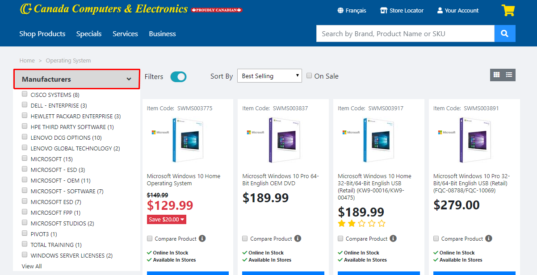

**TABLE NAME: manufacturer**

|  |  |  |  |
| --- | --- | --- | --- |
| **NAME** | **TYPE** | **ALLOW NULL** | **DESC/ATTRIBUTES** |
| manufacturerID | int | NOT NULL | PRIMARY KEY/IDENTITY |
| manufacturerName | varchar (40) | NOT NULL |  |
| Branch_Address | varchar(120) | NOT NULL |  |
| email | varchar(120) | NOT NULL |  |
| contactNumber | varchar(120) | NOT NULL |  |

Script:

CREATE TABLE manufacturer(

manufacturerID INT NOT NULL PRIMARY KEY IDENTITY(1,1),

manufacturerName VARCHAR(40) NOT NULL,

manufacturer_Address VARCHAR(120) NOT NULL,

email VARCHAR(120) NOT NULL,

contactNumber VARCHAR(20) NOT NULL

);

*RELATIONS*

|  |  |  |
| --- | --- | --- |
| **Foreign table** | **Primary table** | **Join** |
| product.productDetails | manufacturer | accountDetails.manufacturerID = product.productDetails.productID |

**PRODUCT CATEGORY**

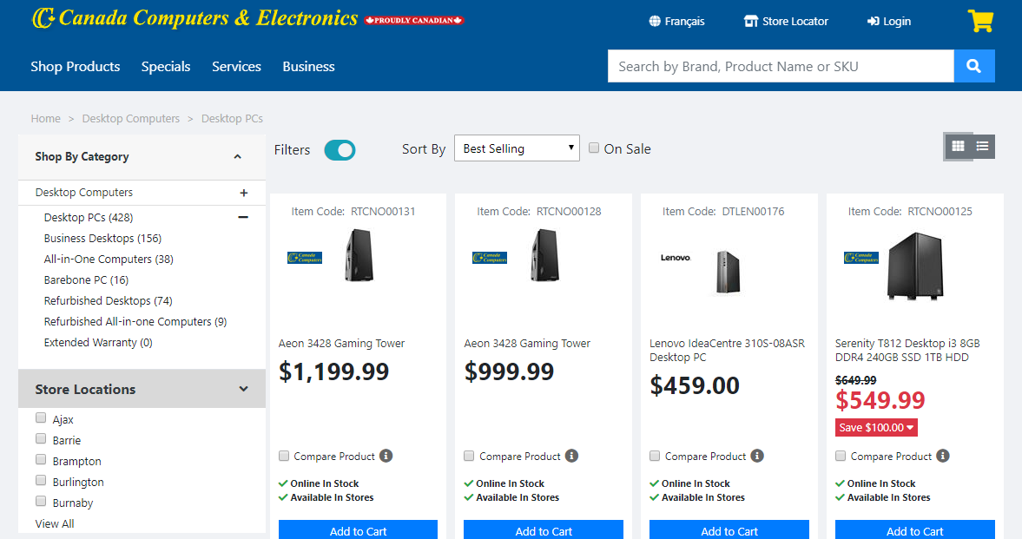

**TABLE NAME: product.category**

|  |  |  |  |
| --- | --- | --- | --- |
| **NAME** | **TYPE** | **ALLOW NULL** | **DESC/ATTRIBUTES** |
| categoryID | int | NOT NULL | PRIMARY KEY/IDENTITY |
| categoryName | varchar (120) | NOT NULL |  |

Script:

CREATE TABLE product.category(

categoryID INT NOT NULL PRIMARY KEY IDENTITY(1,1),

categoryName VARCHAR(120) NOT NULL

);

*RELATIONS*

|  |  |  |
| --- | --- | --- |
| **Foreign table** | **Primary table** | **Join** |
| product.productDetails | product.category | product.category.categoryID = product.productDetails.productID |

**PRODUCT BRAND**

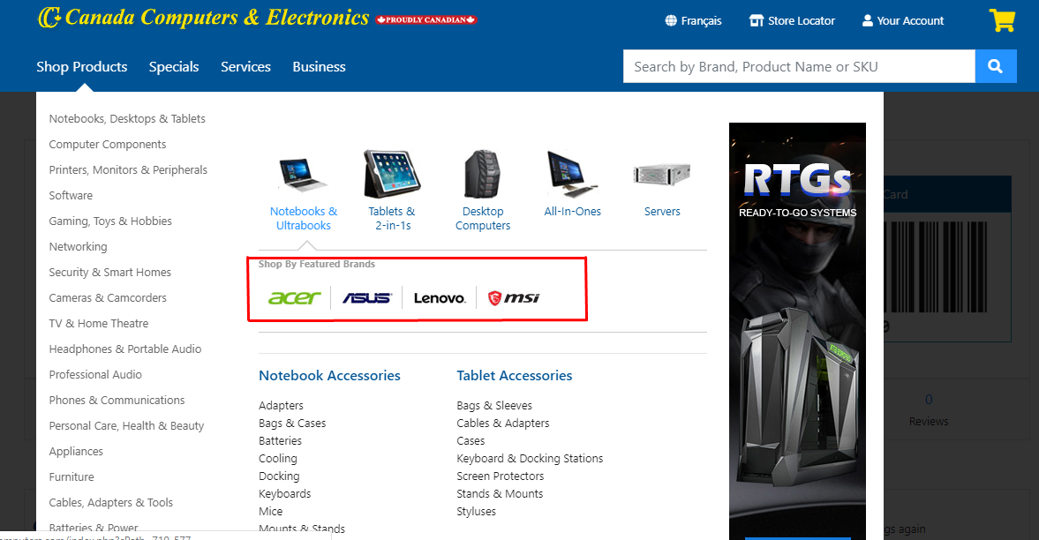

**TABLE NAME: product.brand**

|  |  |  |  |
| --- | --- | --- | --- |
| **NAME** | **TYPE** | **ALLOW NULL** | **DESC/ATTRIBUTES** |
| brandID | int | NOT NULL | PRIMARY KEY/IDENTITY |
| brandName | varchar (120) | NOT NULL |  |

CREATE TABLE product.brand(

brandID INT NOT NULL PRIMARY KEY IDENTITY(1,1),

brandName VARCHAR(120)

);

*RELATIONS*

|  |  |  |
| --- | --- | --- |
| **Foreign table** | **Primary table** | **Join** |
| product.productDetails | product.brand | product.brand.brandID = product.productDetails.productID |

**PRODUCT DETAILS**

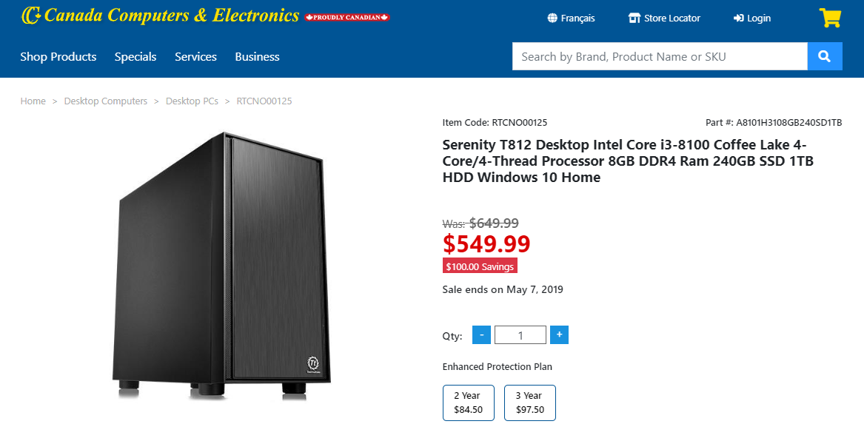

**TABLE NAME: productDetails**

|  |  |  |  |
| --- | --- | --- | --- |
| **NAME** | **TYPE** | **ALLOW NULL** | **DESC/ATTRIBUTES** |
| productID | int | NOT NULL | PRIMARYKEY/IDENTITY |
| productName | varchar(120) | NOT NULL |  |
| productDescription | nvarchar(1) | NOT NULL |  |
| price | decimal (10,2) | NOT NULL |  |
| stockID | int | NOT NULL |  |
| manufacturerID | int | NOT NULL | FOREIGN KEY |
| categoryID | int | NOT NULL | FOREIGN KEY |
| brandID | int | NOT NULL | FOREIGN KEY |

Scrtipt:

CREATE TABLE product.productDetails(

productID INT NOT NULL PRIMARY KEY IDENTITY,

productName VARCHAR(120) NOT NULL,

productDescription NVARCHAR NOT NULL,

price DECIMAL(10, 2) NOT NULL,

manufacturerID INT NOT NULL FOREIGN KEY REFERENCES manufacturer(manufacturerID) ON DELETE CASCADE ON UPDATE CASCADE,

categoryID INT NOT NULL FOREIGN KEY REFERENCES product.category(categoryID) ON DELETE CASCADE ON UPDATE CASCADE,

brandID INT NOT NULL FOREIGN KEY REFERENCES product.brand(brandID) ON DELETE CASCADE ON UPDATE CASCADE

);

RELATIONS

|  |  |  |
| --- | --- | --- |
| **Foreign table** | **Primary table** | **Join** |
| product.productDetails | product.category | product.category.categoryID = product.productDetails.categoryID |
| product.productDetails | product.brand | product. brand.brandID= product.productDetails.brandID |
| product.productDetails | manufacturer | manufacturer.manufacturerID = product.productDetails.manufacturerID |
| product.miscContent | product.productDetails | product.miscContent. productid = product.categoryID |

**PRODUCT MISCELANEOUS**

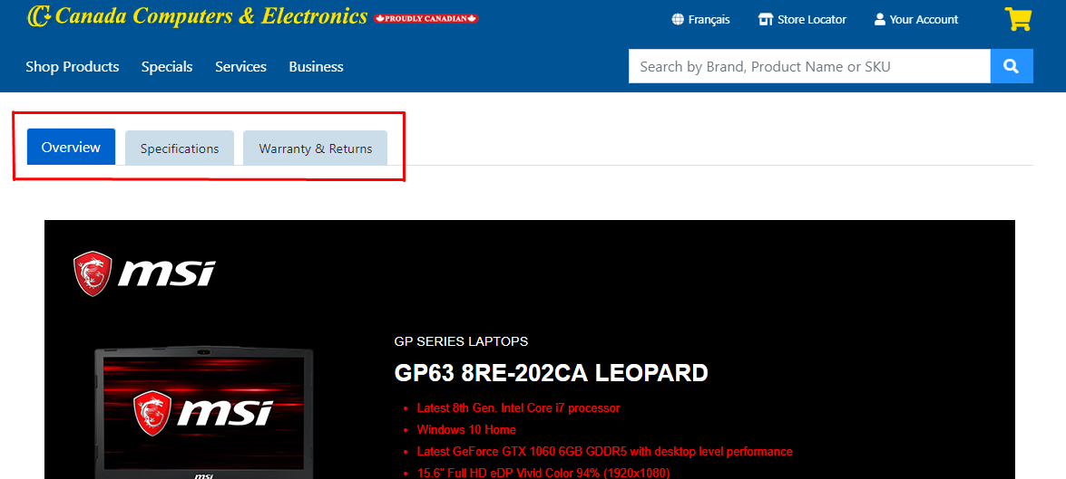

**TABLE NAME: product.productMisc**

|  |  |  |  |
| --- | --- | --- | --- |
| **NAME** | **TYPE** | **ALLOW NULL** | **DESC/ATTRIBUTES** |
| miscID | int | NOT NULL | PRIMARY KEY/IDENTITY |
| label | varchar (120) | NOT NULL |  |

Script:

CREATE TABLE product.productMisc (

miscID INT NOT NULL PRIMARY KEY IDENTITY(1,1),

label VARCHAR(120) NOT NULL

);

*RELATIONS*

|  |  |  |
| --- | --- | --- |
| **Foreign table** | **Primary table** | **Join** |
| product.miscContent | product.productMisc | product.productMisc.miscID = product.product.miscContent miscID |

**PRODUCT MISCELANEOUS CONTENT**

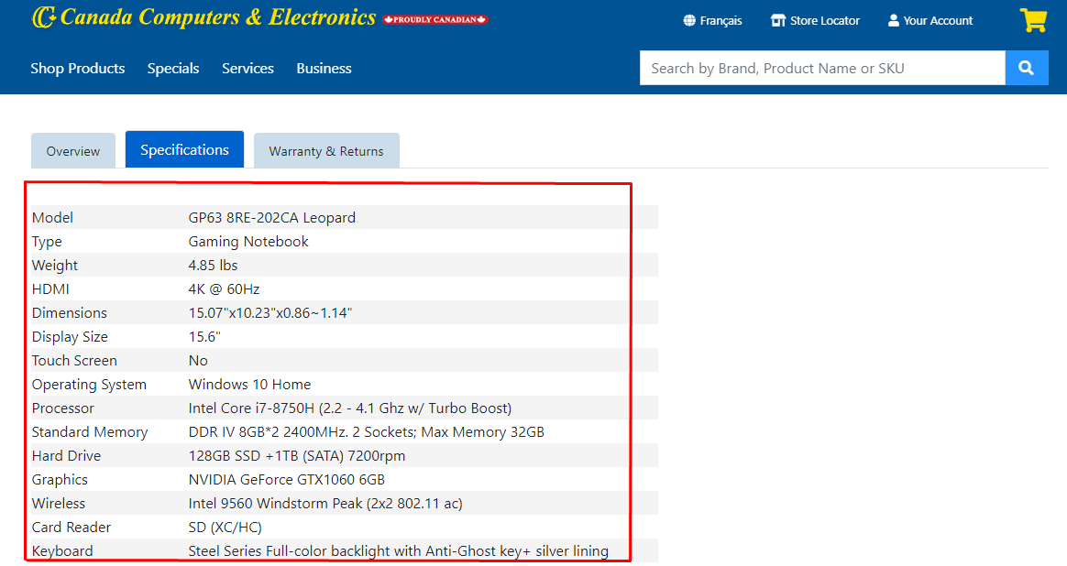

**TABLE NAME: product.miscContent**

|  |  |  |  |
| --- | --- | --- | --- |
| **NAME** | **TYPE** | **ALLOW NULL** | **DESC/ATTRIBUTES** |
| productID | int | NOT NULL | FOREIGN KEY |
| miscID | int | NOT NULL | FOREIGN KEY |
| title | varchar (120) | NOT NULL |  |
| Description | text | ALLOW |  |

Script:

CREATE TABLE product.miscContent(

productID INT NOT NULL FOREIGN KEY REFERENCES product.productDetails(productID) ON DELETE CASCADE ON UPDATE CASCADE,

miscID INT NOT NULL FOREIGN KEY REFERENCES product.productMisc(miscID) ON DELETE CASCADE ON UPDATE CASCADE,

  Title VARCHAR(120) NOT NULL,

  [Description] TEXT NULL

);

*RELATIONS*

|  |  |  |
| --- | --- | --- |
| **Foreign table** | **Primary table** | **Join** |
| product.miscContent | product.productMisc | product.productMisc.miscID = product.product.miscContent miscID |
| product.productDetails | product.miscContent | product.productDetails.productID = product.product.miscContent.productID |

**PRODUCT STOCK**

**TABLE NAME: product.stock**

|  |  |  |  |
| --- | --- | --- | --- |
| **NAME** | **TYPE** | **ALLOW NULL** | **DESC/ATTRIBUTES** |
| productID | int | NOT NULL | FOREIGN KEY |
| branchID | int | NOT NULL | FOREIGN KEY |
| qty | int | NOT NULL |  |

Script:

CREATE TABLE product.stocks(

productID INT NOT NULL FOREIGN KEY REFERENCES product.productDetails(productID) ON DELETE CASCADE ON UPDATE CASCADE,

branchID INT NULL FOREIGN KEY REFERENCES branch(branchID) ON DELETE CASCADE ON UPDATE CASCADE,

qty INT NOT NULL

);

*RELATIONS*

|  |  |  |
| --- | --- | --- |
| **Foreign table** | **Primary table** | **Join** |
| product.stocks | branch | branch.branchID = product.stocks.branchID |
| product.stocks | product.productDetails | branch.productDetails.productID = product.stocks.productID |

**SALES ORDER STATUS**

**TABLE NAME: sales.orderStatus**

|  |  |  |  |
| --- | --- | --- | --- |
| **NAME** | **TYPE** | **ALLOW NULL** | **DESC/ATTRIBUTES** |
| orderStatusID | int | NOT NULL | PRIMARY KEY/IDENTITY |
| label | varchar(12) | NOT NULL |  |

Script:

CREATE TABLE sales.orderStatus(

orderStatusID INT NOT NULL PRIMARY KEY IDENTITY(1,1),

label VARCHAR(12) NOT NULL

);

*RELATIONS*

|  |  |  |
| --- | --- | --- |
| **Foreign table** | **Primary table** | **Join** |
| sales.orders | sales.orderStatus | sales.orderStatus.orderStatusID = sales.orders.orderStatusID |

**SALES ORDERS**

**TABLE NAME: sales.orders**

|  |  |  |  |
| --- | --- | --- | --- |
| **NAME** | **TYPE** | **ALLOW NULL** | **DESC/ATTRIBUTES** |
| orderID | int | NOT NULL | PRIMARY KEY/IDENTITY |
| orderDate | Datetime | NOT NULL | DEFAULT |
| accountID | int | NOT NULL | FOREIGN KEY |
| branchID | int | NOT NULL | FOREIGN KEY |
| orderStatusID | int | NOT NULL | FOREIGN KEY |

Script:

CREATE TABLE sales.orders (

orderID INT NOT NULL IDENTITY (1, 1) PRIMARY KEY,

orderDate DATETIME NOT NULL DEFAULT CURRENT_TIMESTAMP,

accountID INT NOT NULL FOREIGN KEY REFERENCES account(accountID) ON DELETE CASCADE ON UPDATE CASCADE,

branchID INT NULL FOREIGN KEY REFERENCES branch(branchID) ON DELETE CASCADE ON UPDATE CASCADE,

orderStatusID INT NULL FOREIGN KEY REFERENCES sales.orderStatus(orderStatusID) ON DELETE CASCADE ON UPDATE CASCADE

);

*RELATIONS*

|  |  |  |
| --- | --- | --- |
| **Foreign table** | **Primary table** | **Join** |
| sales.orders | sales.orderStatus | sales.orderStatus.orderStatusID = sales.orders.orderStatusID |
| sales.orders | branch | branch.branchID = sales.orders.branchID |
| sales.orders | account | account.accountID = sales.orders.accountID |
| sales.orderItems | sales.orders | sales.orders.orderID = sales.orderItems.orderID |

**SALES ORDER ITEMS**

**TABLE NAME: sales.orderItems**

|  |  |  |  |
| --- | --- | --- | --- |
| **NAME** | **TYPE** | **ALLOW NULL** | **DESC/ATTRIBUTES** |
| orderID | int | NOT NULL | FOREIGN KEY |
| productID | int | NOT NULL | FOREIGN KEY |
| qty | int | NOT NULL |  |
| price | Decimal(10,2) | NOT NULL |  |
| discount | Decimal(4,2) | NOT NULL | DEFAULT 0 |

Script:

CREATE TABLE sales.orderItems(

orderID INT NULL FOREIGN KEY REFERENCES sales.orders(orderID) ON DELETE CASCADE ON UPDATE CASCADE,

productID INT NOT NULL FOREIGN KEY REFERENCES product.productDetails(productID) ON DELETE CASCADE ON UPDATE CASCADE,

qty INT NOT NULL,

price DECIMAL (10, 2) NOT NULL,

discount DECIMAL (4, 2) NOT NULL DEFAULT 0

);

*RELATIONS*

|  |  |  |
| --- | --- | --- |
| **Foreign table** | **Primary table** | **Join** |
| sales.orderItems | product.productDetails | sales.orderItems.productID = product.productDetails.productID |
| sales.orderItems | sales.orders | sales.orderItems.orderID = sales.orders.orderID |

**PRESETS**

INSERT INTO accountType(accountTypeName) VALUES ('admin'), ('staff'), ('customers'), ('suppliers');

GO

INSERT INTO accountStatus (label) VALUES ('active'), ('inactive'), ('deactivate');

GO

INSERT INTO product.productMisc(label) VALUES ('Overview'),('Specifications'),('Warranty & Returns');

GO

INSERT INTO sales.orderStatus(label) VALUES ('Pending'), ('Processing'), ('Rejected'), ('Completed');

GO

**TRIGGERS**

CREATE TRIGGER accountCreatedTrigger

ON account

FOR INSERT

AS

BEGIN

DECLARE @accountID INT

SELECT @accountID = accountID FROM inserted

INSERT INTO accountCreated

VALUES(CAST(@accountID AS NVARCHAR(5)),CAST(GETDATE() AS NVARCHAR(20)))

END;

Definition:

I create a triggers function to add date in accountCreatedTrigger table when account is created in account table.

**DIAGRAM**

